# Introduction to Digital Logic Design Lab EECS 31L

Lab 4:

Pipeline processor

2/25/2021

## 1 Objective

In this lab, I designed a pipeline processor. By using a pipeline processor, compared to a single cycle processor, we can get a better performance by pipelining instructions.

## 2 Procedure

**Implementing**

One of the most different part between a pipeline and a sigle cycle processor is that pipleline processor has 4 registers called IF/ID, ID/EX, EX_MEM, MEM_WB.

There were 5 parts that I revised. 1, IF_pipe_stage. 2, ID_pipe_stage. 3, EX_pipe_stage. 4, EX_forwarding_unit. 5, hazard_detection. 6, mips_32.

For IF_pipe_stage, I added 2 mux that used for branch (sel: branch_taken) and jump (sel: jump), and defined pc_reg. I calculated pc_plus 4 by adding 4 and pc_reg. The other output instr is generated by instruction_mem. I connected them by pipe_reg_en.

For IF/ID REG, I connected output from IF (pc_plus4, instr) and other 4 inputs (clk, reset, en(data_hazard), flush(IF_Flush) )as the input, and created 2 outputs (if_id_pc_plus4, if_id_instr).

For ID_pipe stage, there were 8 inputs (clk,reset, if_id_instr, pc_plus4, mem_wb_reg_write, mem_wb_write_back_data, mem_wb_write_reg_addr, Data_Hazard, Control_Hazard) and 13 outputs (reg1, reg2,mm_value,branch_address,jump_address,branch_taken,destination_reg,mem_to_reg,alu_op,mem_read, mem_write,alu_src,reg_write,jump) I connected the input and output based on the description of lab manual. There were 4 modules inside ID_pipe_stage: reg, control, sign-extend, and control, and there were all related to instr. Control was connected to instr[31:26], its ouput mem_to_reg, mem_read, mem_write, alu_scr, reg_write were control by a mux connected to (~(Data_Hazard) | Control_Hazard), and jump is a direct ouput, and Branch was connected to a AND gate. Instr[25:0] was shifted by 2 and directly generated a ouput called jump_address. Pc_plus 4 was added with sign-exteneded instr[15:0] shifted left 2 and their sum was a output called branch_address. Instr[25:21] ,instr[20:16], and mem_wb_reg_write, mem_wb_write_reg_addr and mem_wb_write_back_data were connected to internal module Reg_File as 5 inputs. The 2 outpus of Reg_File were called reg1 and reg2, and also both were connected to a Eq_test module and AND with a branch to generate a ouput called branch_taken. The ouput imm_value was sign-extened from instr[15:0] and destination_reg was generated by mux2(a: instr[20:16], b:instr[15:11],sel:reg_dst from control)

For ID/EX reg, there were 11 inputs and 11 outputs, I just directly connected them by pipe_reg.

For Harzard_Detection module, the code was provided so I copy/paste the code directly.

For execution module, there were 4 internal modules called mux2, mux4, alu_control and alu. 8 inputs (id_ex_instr,reg1,reg2,id_ex_imm_value,ex_mem_alu_result,mem_wb_write_back_result,id_ex_alu_src,id_ex_alu_op,Forward_A, Forward_B) and 2 outputs (alu_in2_out, alu_result) were there. Alu_control’s 2 input were id_ex_instr[5:0] and id_ex_alu_op, its output alu_control was connected to alu. There were 2 mux4 Mux4 1(mem_wb_write_back_result), .c(ex_mem_alu_result), .sel(Forward_A), and its output went to the alu. Mux4 2 mem_wb_write_back_result), .c(ex_mem_alu_result), .sel(Forward_B) and its output went to the execution output called alu_int_out. Another mux2 (.a(mux2_output), .b(id_ex_imm_value),

.sel(id_ex_alu_src)) was also there and its output was the other input of alu. Alu’s output was the one of the outputs of execution called alu_result.

For forwarding unit, there were 6 inputs (ex_mem_reg_write,ex_mem_write_reg_addr,id_ex_instr_rs,

id_ex_instr_rt,mem_wb_reg_write,mem_wb_write_reg_addr)and 2 outputs(Forward_A, forward_B). I then directly translated the logic in the lab manual to Verilog code.

For EX.MEM REG, there were 8 inputs and 8 outputs and I directly connected them by pipe_reg.

For Memory (Data_memory), there were 5 inputs (clk,mem_access_addr,mem_write_data,

mem_write_en,mem_read_en, )and 1 output(mem_read_data). I connected them with the module data_memory directly with those wires.

For MEM/WB REG, there were 5 inputs and 5 outputs, and I directly connected them with pipe_reg.

For Write back. There were 3 inputs and 1 output (.a(mem_wb_alu_result),

.b(mem_wb_mem_read_data), .sel(mem_wb_mem_to_reg), .y(write_back_data), and I connected them by a Mux. The ouput of this mux also was the ouput of the processor.

**Debugging**

One of the most challenging things to do in this lab was to debug the code because this project was complicated, and a lot of wires were connected. It took me 4 hours total to debug this stuff.

When I just finished writing my code, I was not able to get it simulated because there were several errors in my code. I forgot to name each module I used in mips_32. After I got all errors fixed, I was able to run it.

I only got 3 success at the first time. Firstly, I checked console at the bottom of the screen and found a lot of warming regarding the bits of mux. I realized that I defined the width of some mux in a wrong way. After I fixed that and had zero warming, I still got 3 success.

I was stuck at that time and I went to my mips_32 code, 3 hours later, I found I swapped the definition of 2 of the wires. Lastly, I was able to get all success.

## 3 Simulation Results

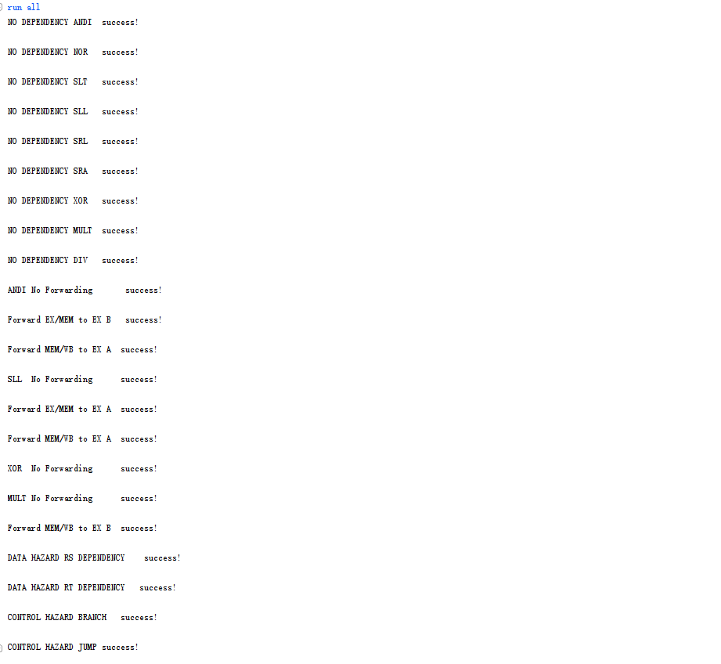

**According to the Testbench, we firstly put some data for the processor.**

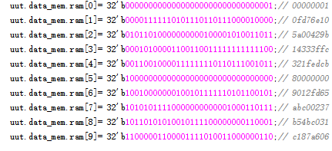

**Then, if all the tests were passed, there will have the following results in the data memory.**

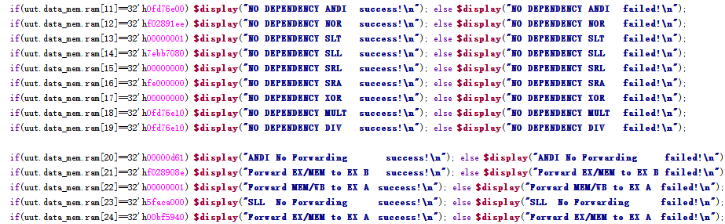

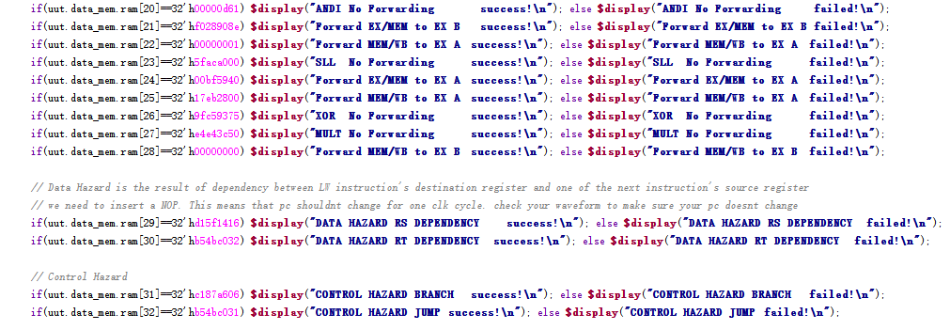

**Then, go back to the wave form of my data memory.**

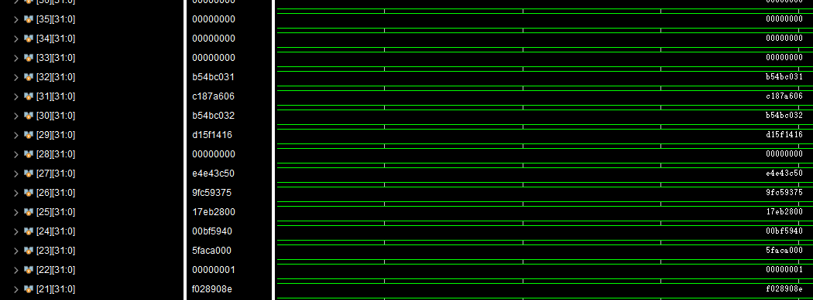

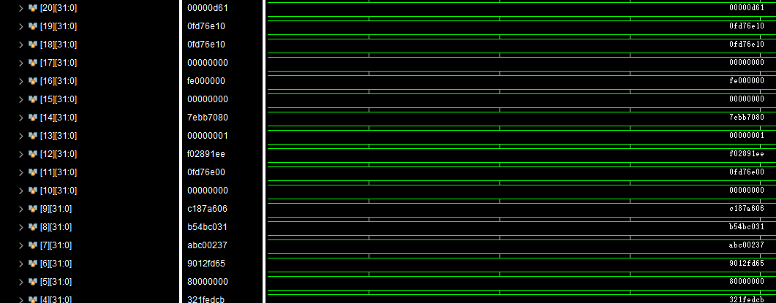

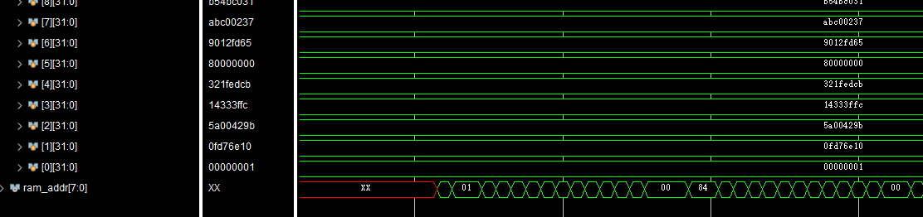

**By comparing the actually results displayed in the waveform and the expected results, all results were verified and therefore the simulation was success.**

